Name : ibraheem Qasim

Sap id : 42896

Section : BSCS 5

Acp

Lab task 9

Task 1

Code :

class PrintHello extends Thread {  
   
 public void run() {  
 for (int i = 0; i < 5; i++) {  
 System.*out*.println("Hello from thread");  
 }  
 }  
}  
public class Main {  
 public static void main(String[] args) {  
 PrintHello thread = new PrintHello(); // Create thread object  
 thread.start();  
  
  
  
 }  
}

output screenshot :

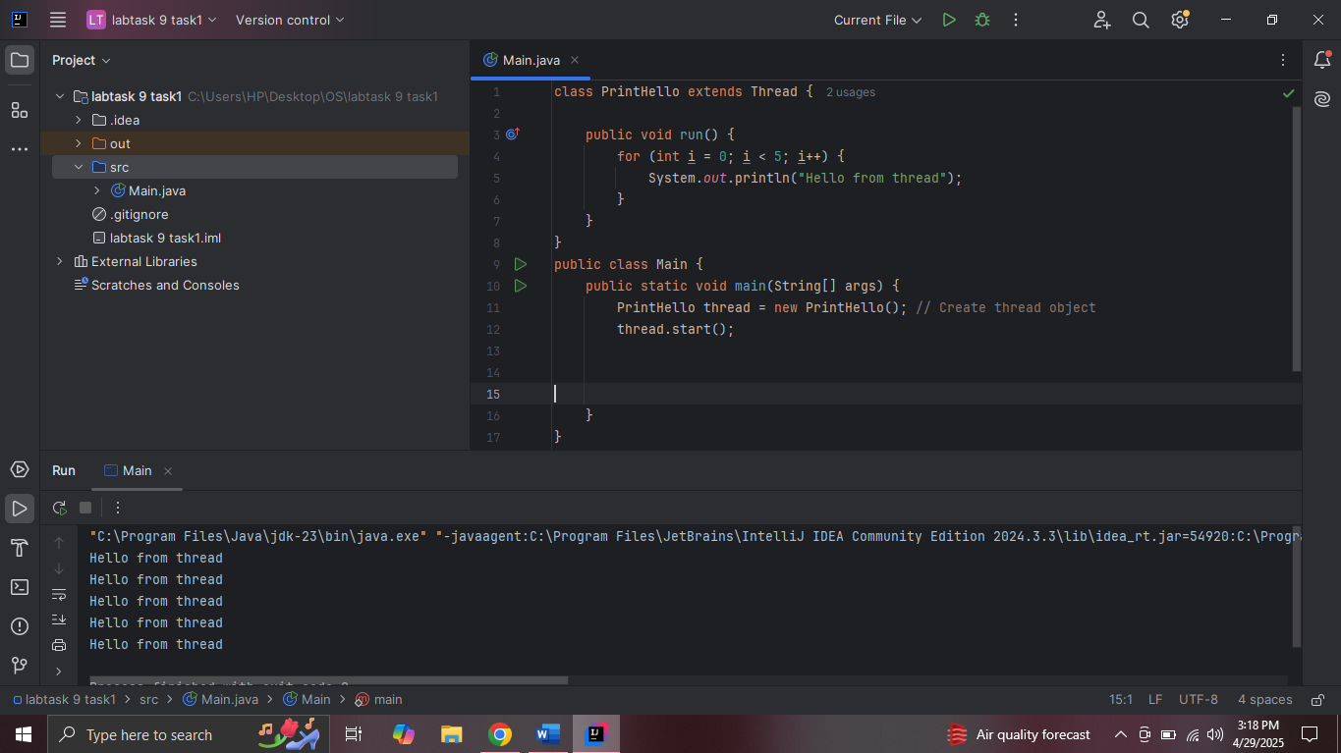

Task 2

Code :

class CounterTask implements Runnable {  
  
 public void run() {  
 for (int i = 1; i <= 10; i++) {  
 System.*out*.println("Number: " + i);  
 try {  
 Thread.*sleep*(500);  
 } catch (InterruptedException e) {  
 System.*out*.println("Thread interrupted: " + e.getMessage());  
 }  
 }  
 }  
}  
public class Main {  
 public static void main(String[] args) {  
 CounterTask task = new CounterTask();  
 Thread thread = new Thread(task);  
 thread.start();  
 }  
  
  
  
  
 }

output :

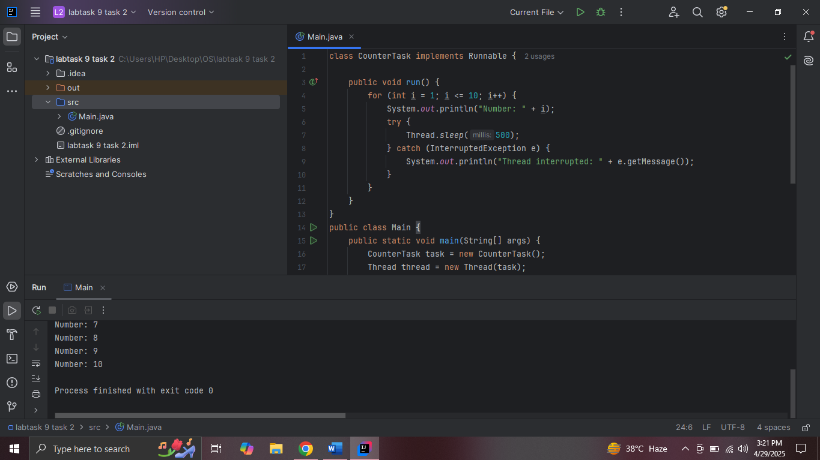

Task 3

class EvenPrinter implements Runnable {  
 public void run() {  
 for (int i = 0; i <= 10; i += 2) {  
 System.*out*.println("Even: " + i);  
 }  
 }  
}  
  
class OddPrinter implements Runnable {  
 public void run() {  
 for (int i = 1; i < 10; i += 2) {  
 System.*out*.println("Odd: " + i);  
 }  
 }  
  
 public static void main(String[] args) {  
 Thread evenThread = new Thread(new EvenPrinter());  
 Thread oddThread = new Thread(new OddPrinter());  
 evenThread.start();  
 oddThread.start();  
 }  
}

output screenshot :

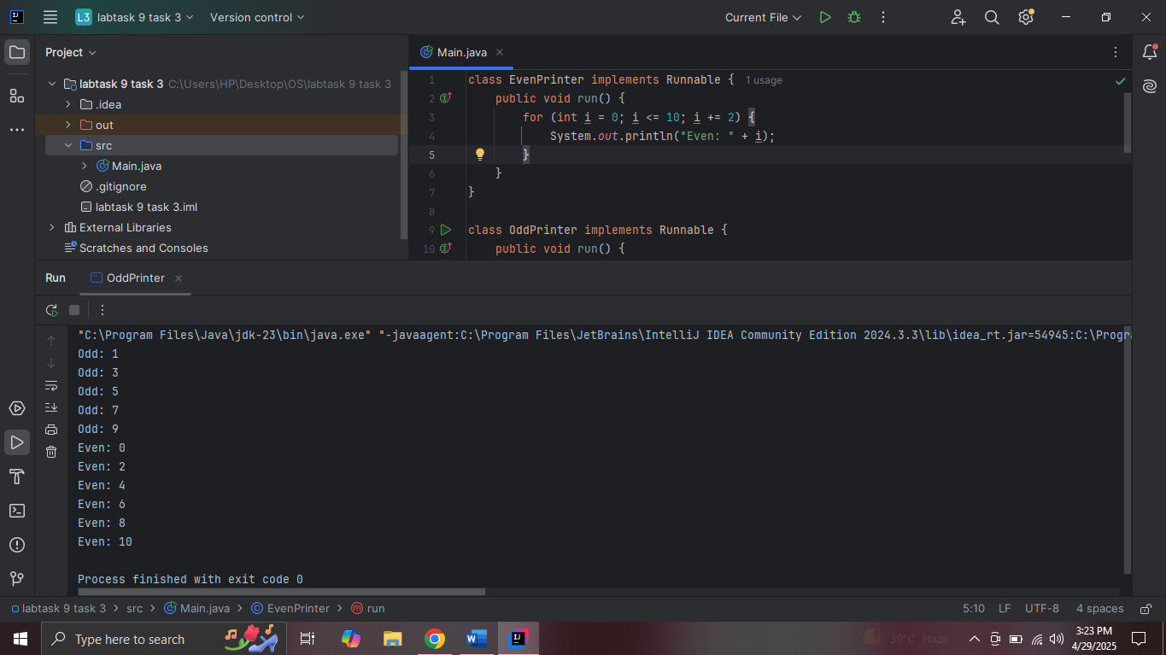

Task 4

Code

class WorkerThread extends Thread {  
 public void run() {  
 System.*out*.println("Running thread: " + Thread.*currentThread*().getName());  
 }  
  
 public static void main(String[] args) {  
 WorkerThread thread = new WorkerThread();  
 thread.setName("WorkerThread");  
 thread.start();  
  
 System.*out*.println("Main thread name: " + Thread.*currentThread*().getName());  
 }  
}

output :

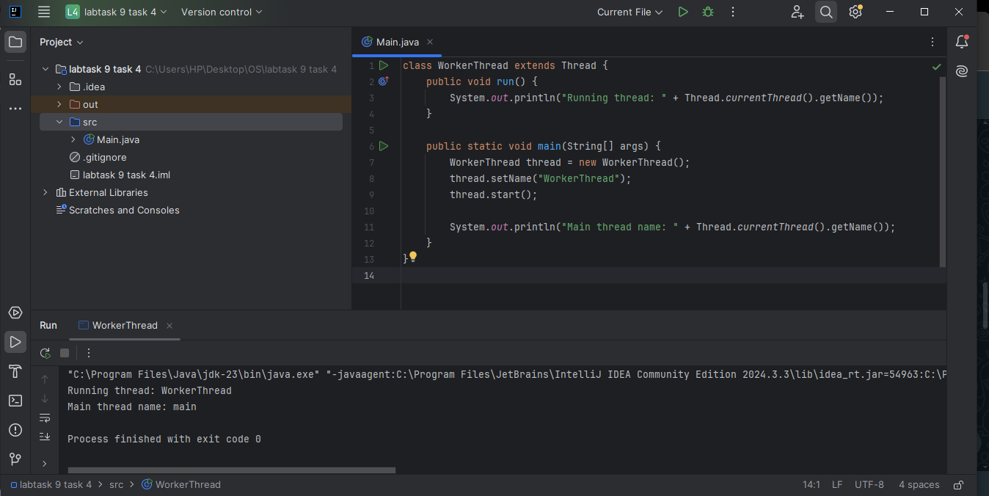

Lab task 5

Code

class SleepThread extends Thread {  
 public void run() {  
 for (int i = 0; i < 5; i++) {  
 System.*out*.println("Working...");  
 try {  
 Thread.*sleep*(2000);  
 } catch (InterruptedException e) {  
 System.*out*.println("Interrupted");  
 }  
 }  
 }  
  
 public static void main(String[] args) {  
 SleepThread thread = new SleepThread();  
 thread.start();  
 }  
}

output :

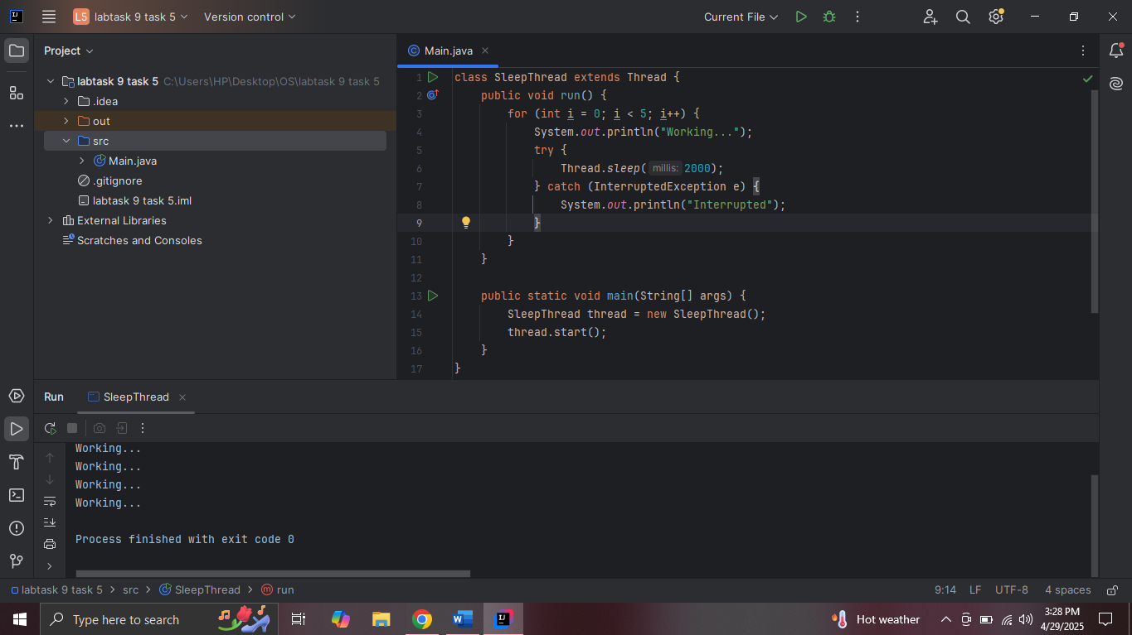

Lab task 6

Code :

class PriorityThread extends Thread {  
 public void run() {  
 for (int i = 0; i < 3; i++) {  
 System.out.println(getName() + " running");  
 }  
 }  
  
 public static void main(String[] args) {  
 PriorityThread t1 = new PriorityThread();  
 t1.setName("Low");  
 t1.setPriority(Thread.MIN_PRIORITY);  
  
 PriorityThread t2 = new PriorityThread();  
 t2.setName("Normal");  
 t2.setPriority(Thread.NORM_PRIORITY);  
 PriorityThread t3 = new PriorityThread();  
 t3.setName("High");  
 t3.setPriority(Thread.MAX_PRIORITY);  
  
 t1.start();  
 t2.start();  
 t3.start();  
 }  
}

output :

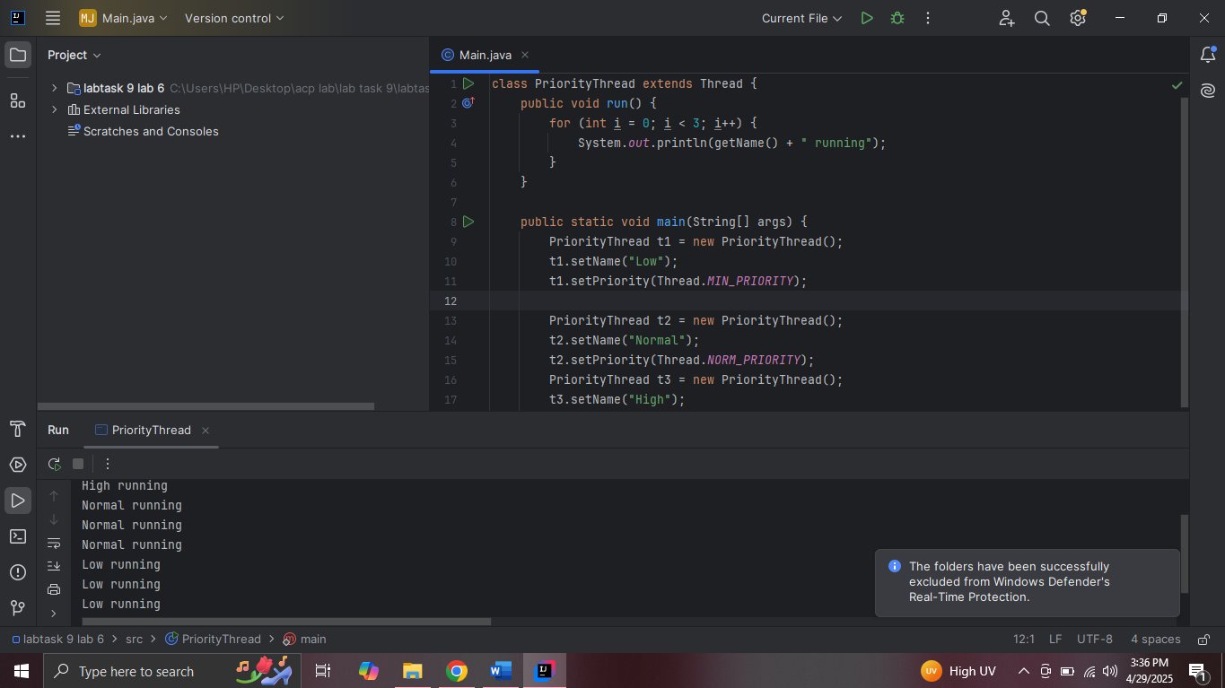

Task 7 :

Code :

class Worker1 extends Thread {  
 public void run() {  
 System.*out*.println("Worker1 running");  
 }  
}  
  
class Worker2 extends Thread {  
 public void run() {  
 System.*out*.println("Worker2 running");  
 }  
  
 public static void main(String[] args) {  
 Worker1 t1 = new Worker1();  
 Worker2 t2 = new Worker2();  
  
 t1.start();  
 try {  
 t1.join();  
 } catch (InterruptedException e) {  
 System.*out*.println("Join interrupted");  
 }  
 t2.start();  
 }  
}

output :

